Experiment 7: Instrumentation Amplifier

NAME: Mansi Uniyal

Roll no.: 19EE10039

Date: 22 March 2021

* Objective: To study the characteristics of an Instrumentation Amplifier.
* Theory:

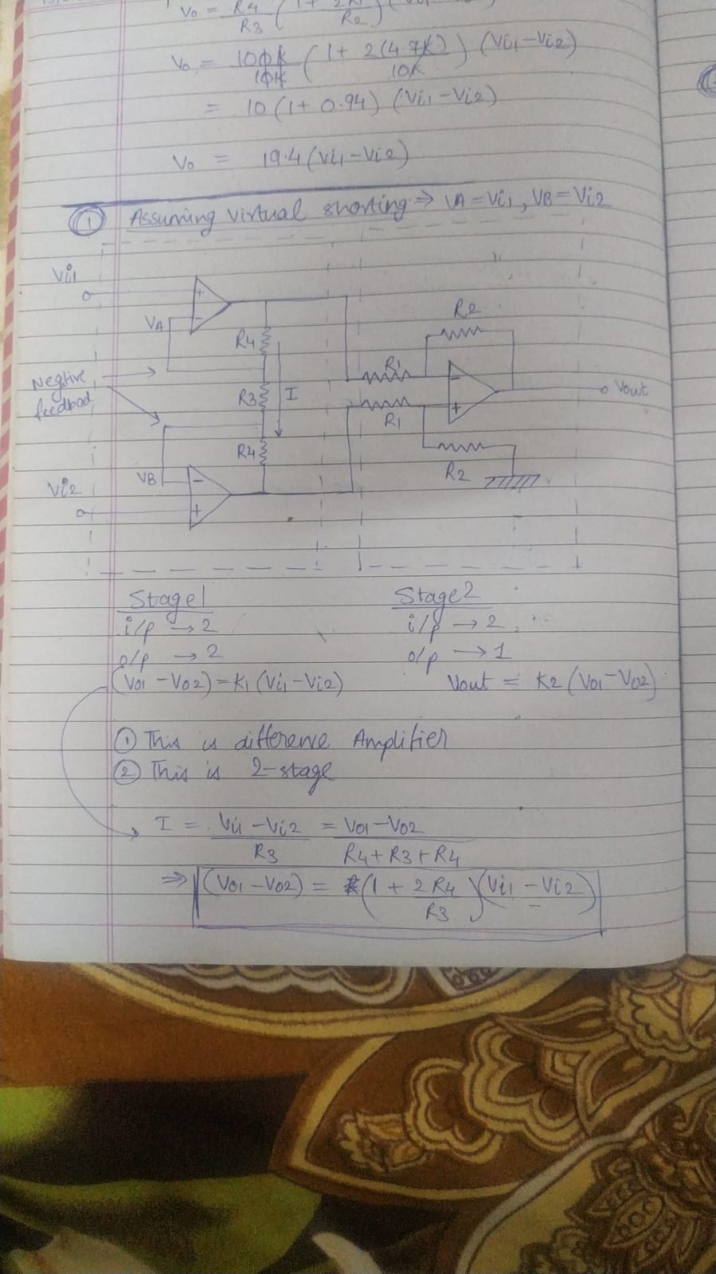

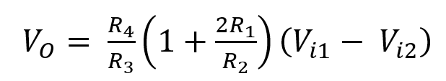

Vo = Acm * (Vi1 + Vi2)/2 + Ad * (Vi1 - Vi2)

R4/R3 (1 + 2R1/R2) = Acm/2 + Ad

R4/R3 (1 + 2R1/R2) = - (Acm/2 - Ad) = - Acm/2 + Ad

Ad = R4/R3 (1 + 2R1/R2)

Acm = 0

CMRR = Ad/Acm = infinite

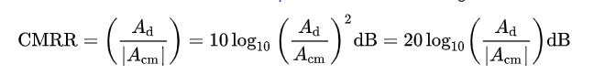

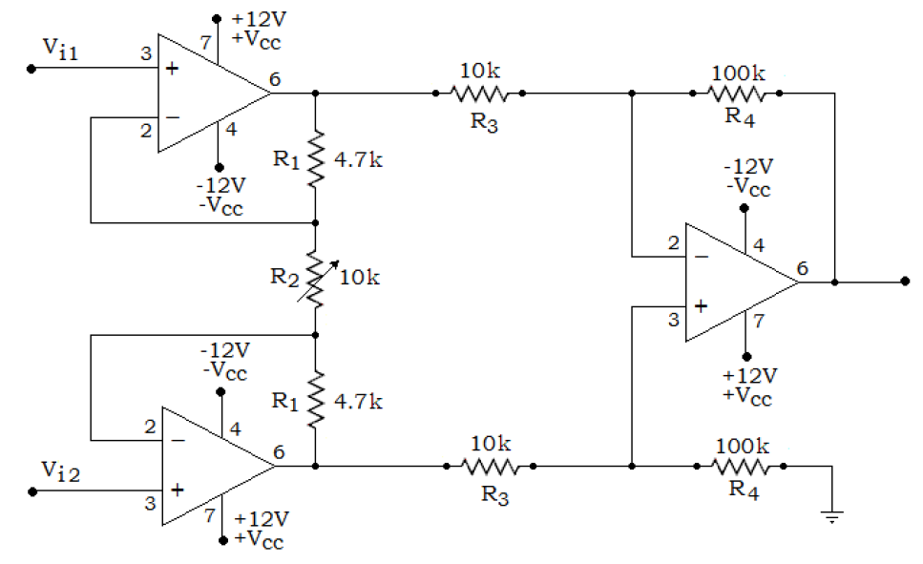

* Simulation Assignment:

1. Draw neatly the above circuit in LTSpice. Use the value of the resistor with 1% tolerance and OP777 op-amp from the component library. Report the values of the resistors used, it should be different from the values used in the reference below.

Answer

R1 = 12k, R2 = 120k, R3 = 120k, R4 = 12k, R5 = 5.2k, R6 = 12k, R7 = 5.2k

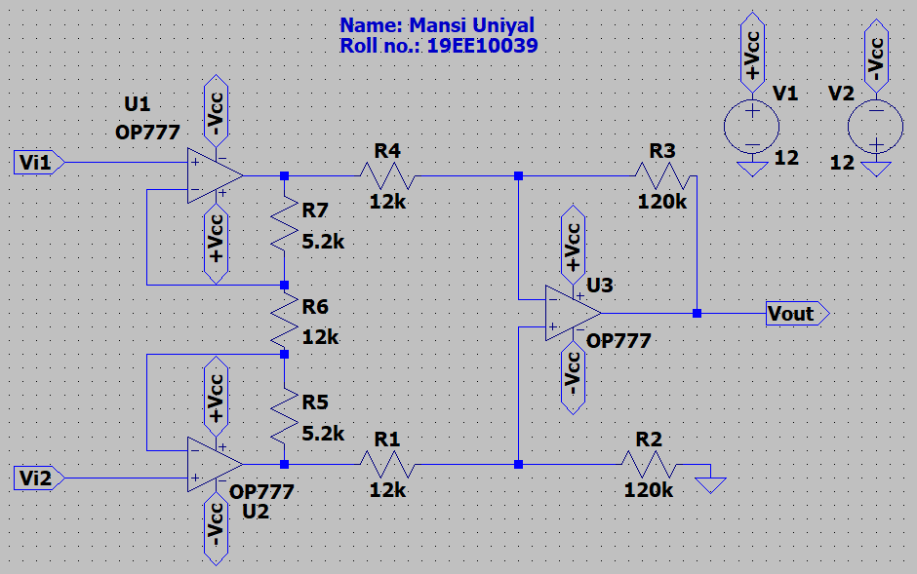

1. Connect both the input terminals to a dc voltage source Vi as shown in the reference below. Vary the dc voltage source Vi from -10 V to +10 V in a step of 1 V and note the output voltage VOUT. Attach the screen-shot of the dc plot VOUT Vs Vin and the snapshot of the schematic as shown in the figure below. Comment on the result.

Answer

It is observed that the Vout increases linearly with an increase in Vin. However, Vout varies from 1mV to 1.2mV for change in Vin from -10V to 10V. Ideally, Vout should be 0. But due to the wiring of OpAmp, we do not observe an ideal behaviour. The slope comes out to be 1.07404e-005. Which signifies it is almost horizontal.

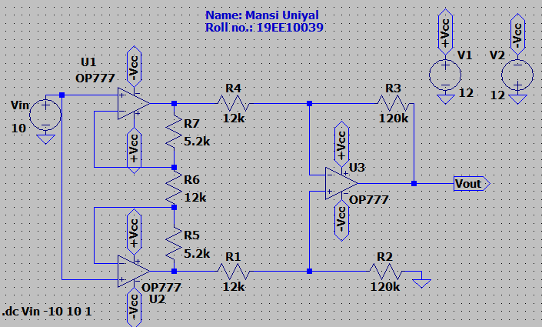

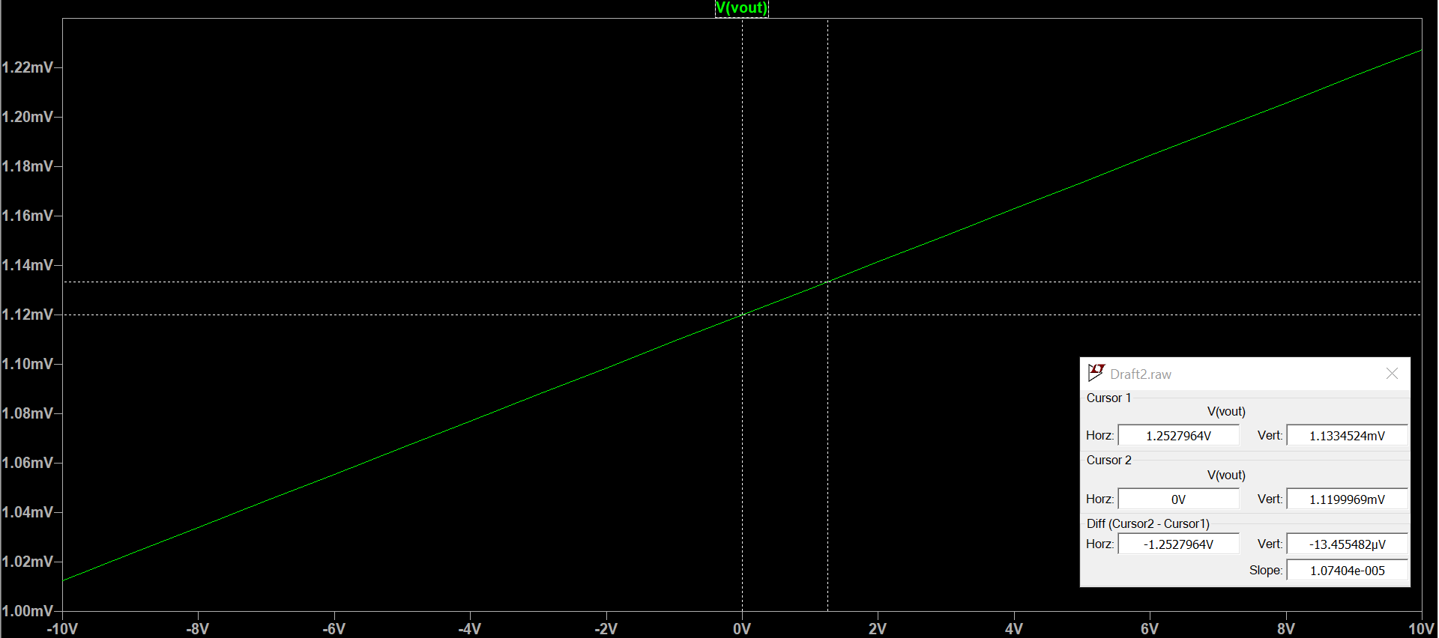

3. i) Apply a differential signal Vd having 20 mV p-p sinusoidal voltage. Vary its frequency as follows: 10 Hz, 100 Hz, 1 kHz, 10 kHz, 100 kHz and 200 kHz. Plot the output VOUT corresponding to the different input frequencies and attach the screen-shot as shown in the figure below. Compute the small-signal AC differential gain for different frequencies. Make a table as shown in the reference below.

|  |  |  |
| --- | --- | --- |
| Frequency Hz | Absolute gain= V/V | Gain in dB= dB |
| 10 | 18.6345 | 25.4064 |
| 100 | 18.6395 | 25.4087 |
| 1000 | 18.6370 | 28.4075 |
| 10000 | 18.4065 | 25.2994 |
| 100000 | 9.652 | 19.6923 |
| 200000 | 5.0120 | 14.0002 |

f=10Hz:

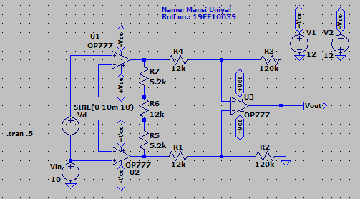

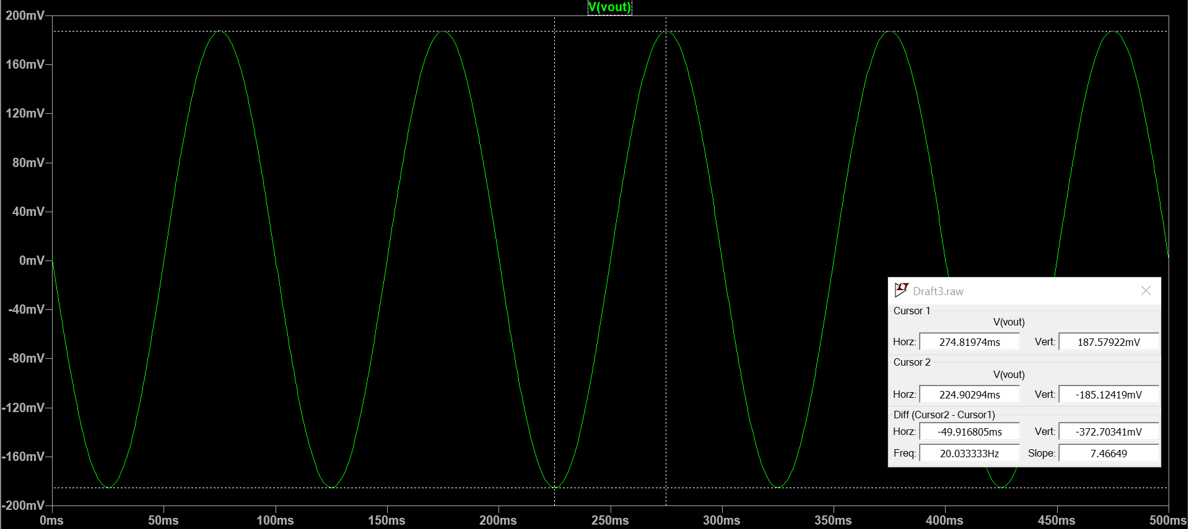

f=100Hz:

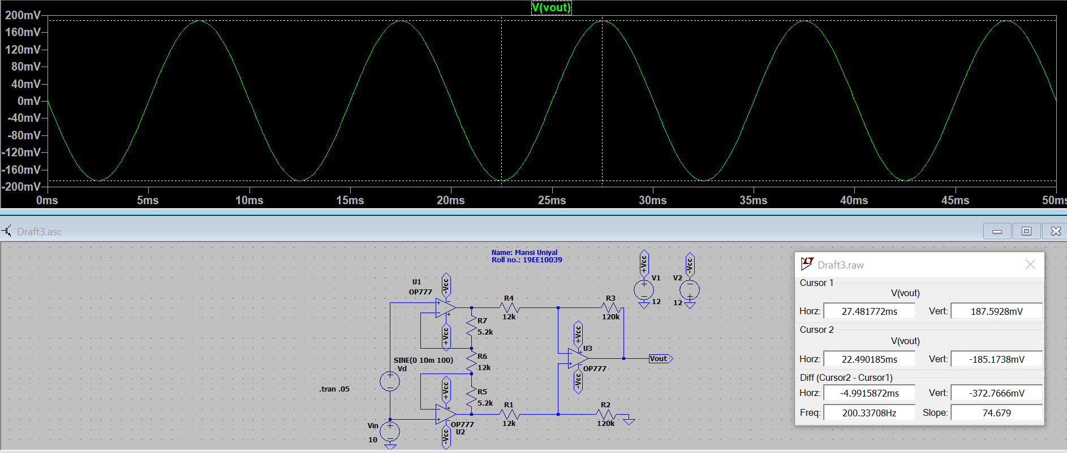

f=1000Hz:

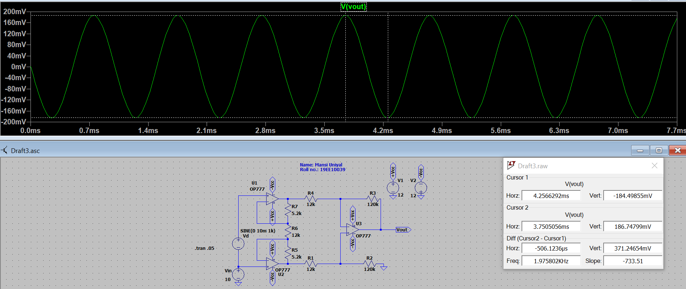

f=10000Hz:

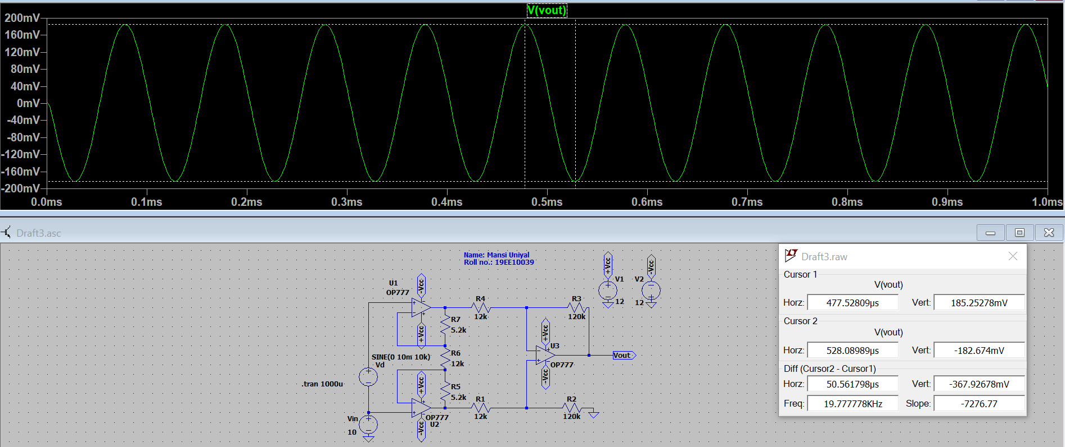

f=100000Hz:

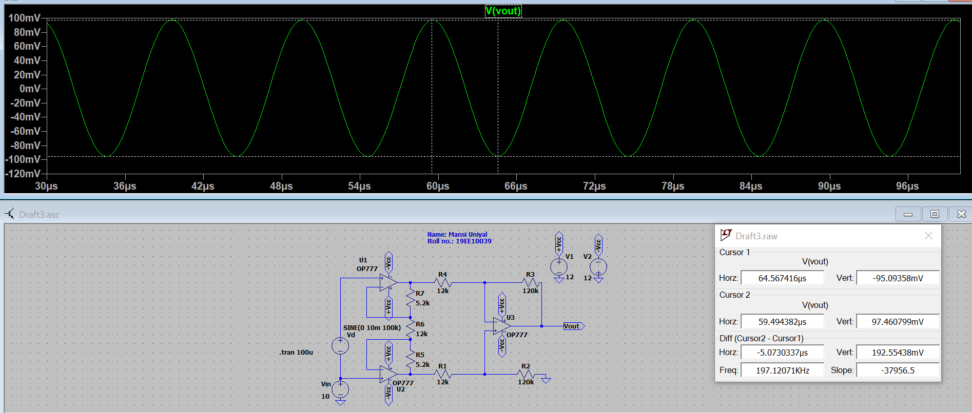

f=200000Hz:

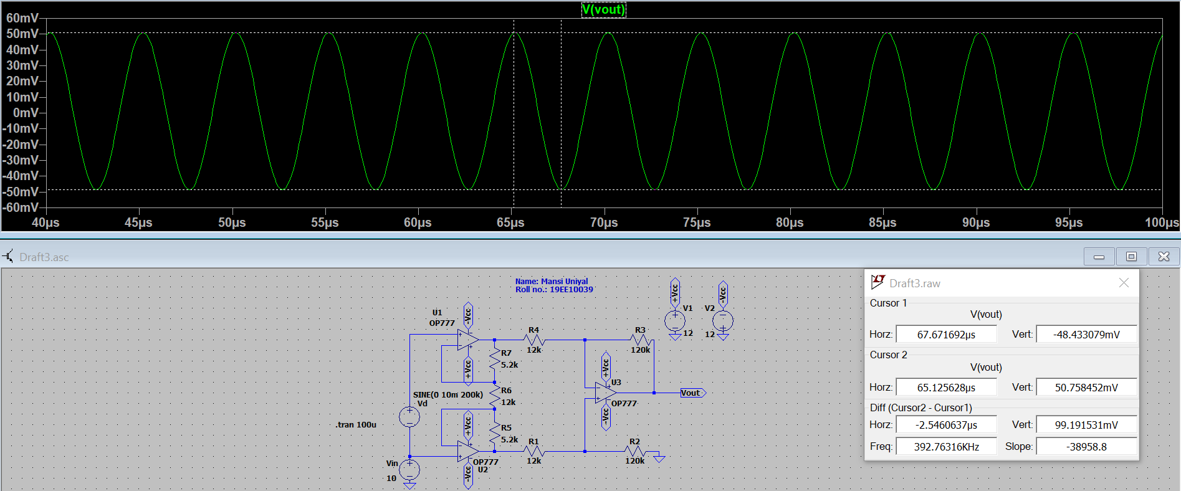

ii) Plot the frequency response in logarithmic and dB scale as shown in the figure below. Compare the value of the gain with the obtained value in the previous table. Report the 3-dB bandwidth form the plot.

3-dB Bandwidth = 63.09kHz

|  |  |  |  |
| --- | --- | --- | --- |
| Frequency Hz | Gain in dB= dB | Gain from Bode Plot dB | %Error in Gain |
| 10 | 25.4064 | 25.4213 | 0.06% |
| 100 | 25.4087 | 25.4213 | 0.01% |
| 1000 | 28.4075 | 25.4202 | 0.05% |
| 10000 | 25.2994 | 25.3140 | 0.06% |
| 100000 | 19.6923 | 19.7905 | 0.49% |
| 200000 | 14.0002 | 14.1187 | 0.84% |

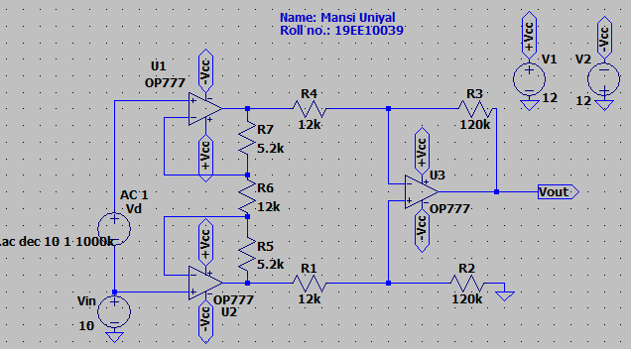

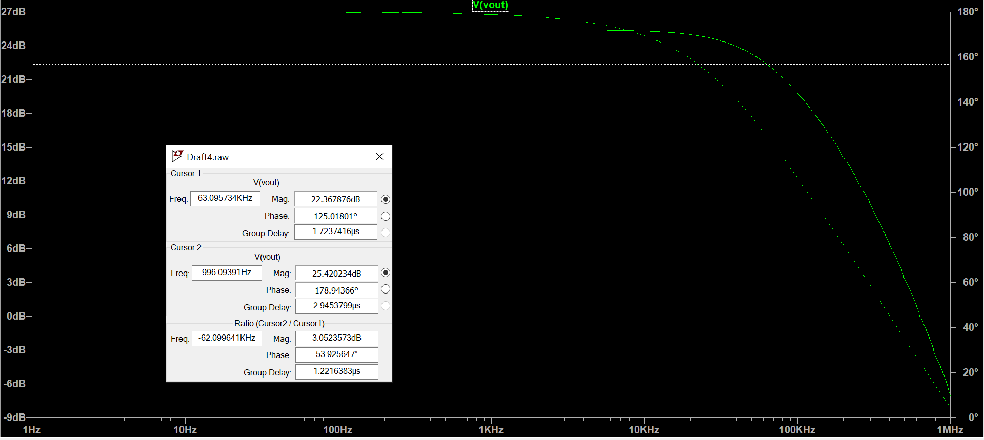

1. Apply a 10 V p-p sinusoidal signal Vi as a common-mode input. Plot the transient waveforms of VOUT with different frequencies of the signal Vi from 10 Hz to 100 Hz in the steps of 10 Hz. Attach the screen-shot as shown in the figure below. Compute the CMRR in dB and comment on the results.

|  |  |  |  |
| --- | --- | --- | --- |
| Frequency Hz | Differential Gain Ad (absolute) | Common Mode Gain Acm (absolute) | CMRR = dB |
| 10 | 18.666 | 10.738μ | 124.802 |
| 20 | 18.666 | 10.827μ | 124.731 |
| 30 | 18.666 | 10.940μ | 124.641 |
| 40 | 18.666 | 11.103μ | 124.512 |
| 50 | 18.666 | 11.238μ | 124.407 |
| 60 | 18.666 | 11.551μ | 124.169 |
| 70 | 18.666 | 11.846μ | 123.950 |
| 80 | 18.666 | 12.118μ | 123.752 |
| 90 | 18.666 | 12.517μ | 123.471 |
| 100 | 18.666 | 12.906μ | 123.205 |

f=10Hz:

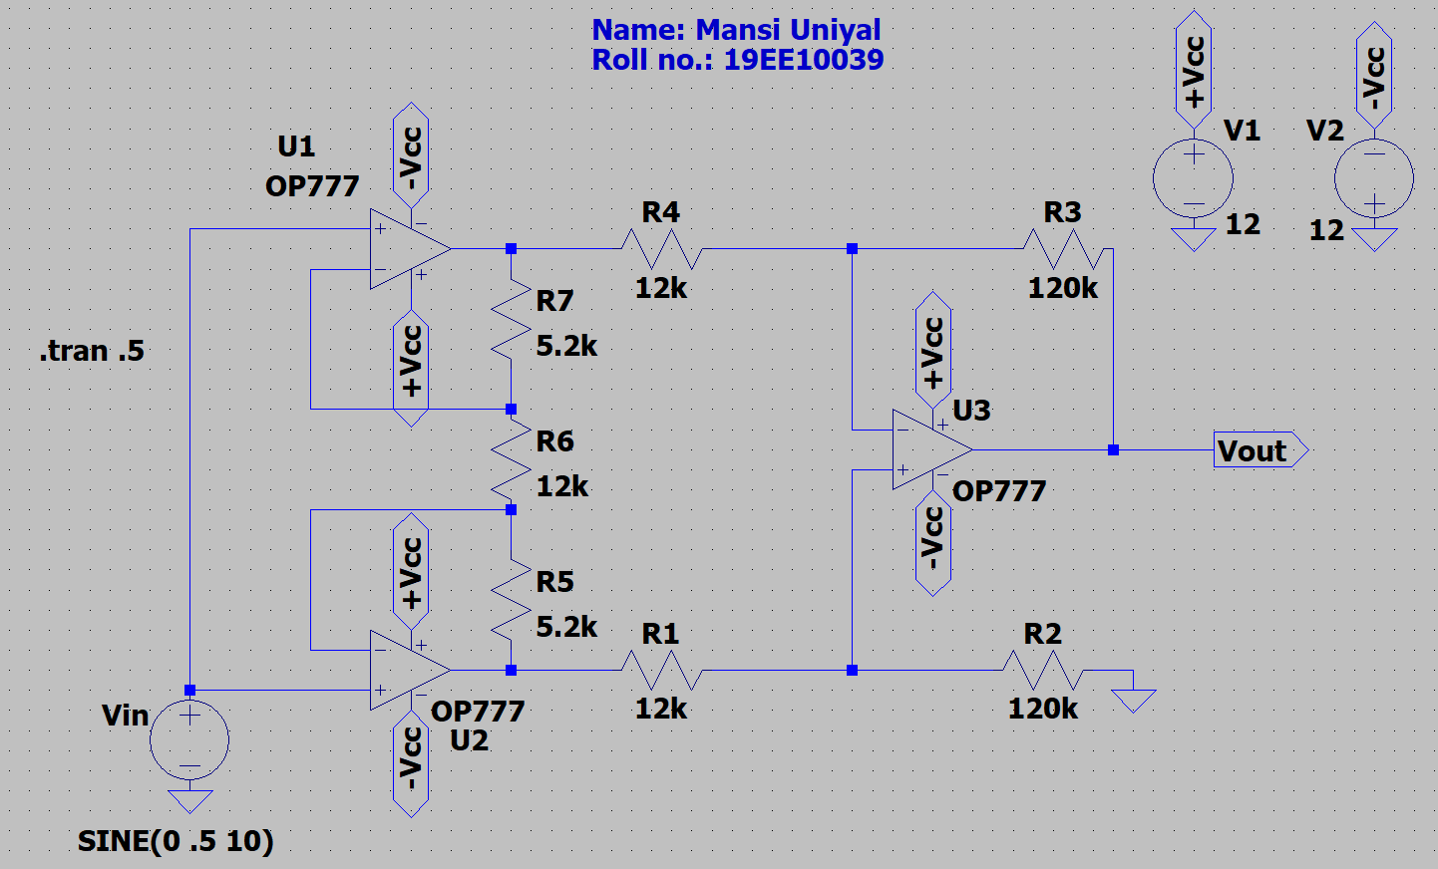

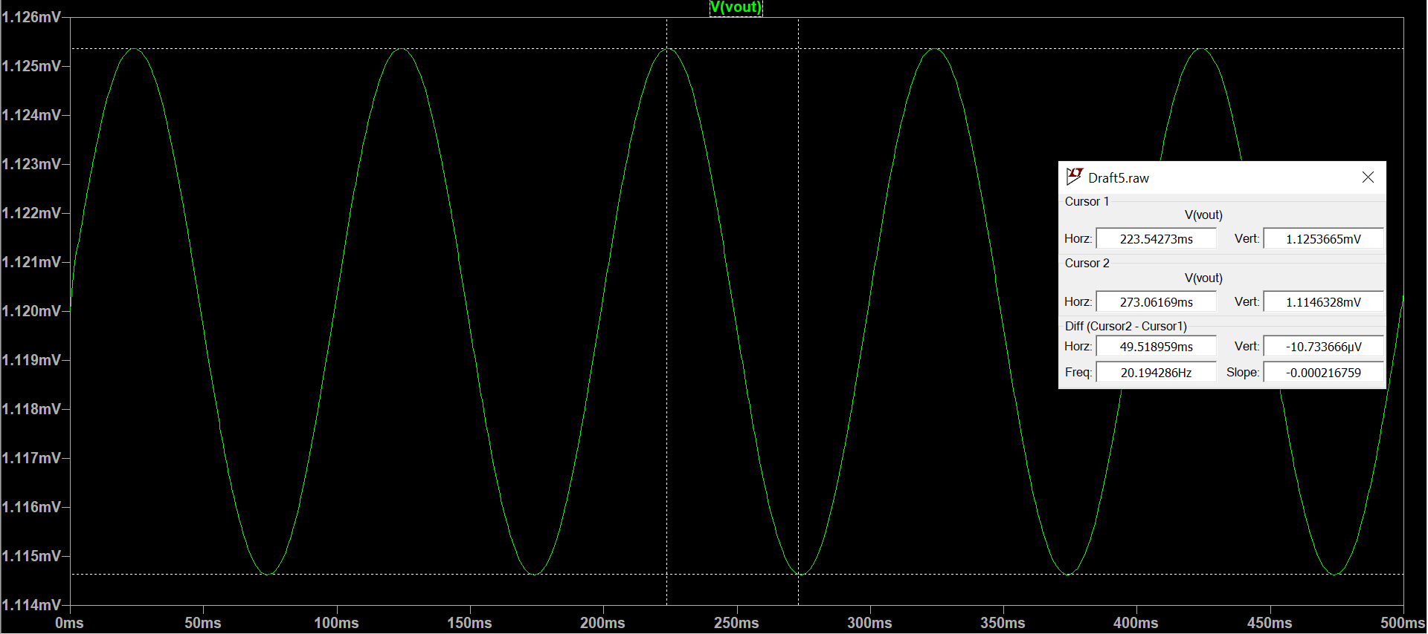

f=20Hz:

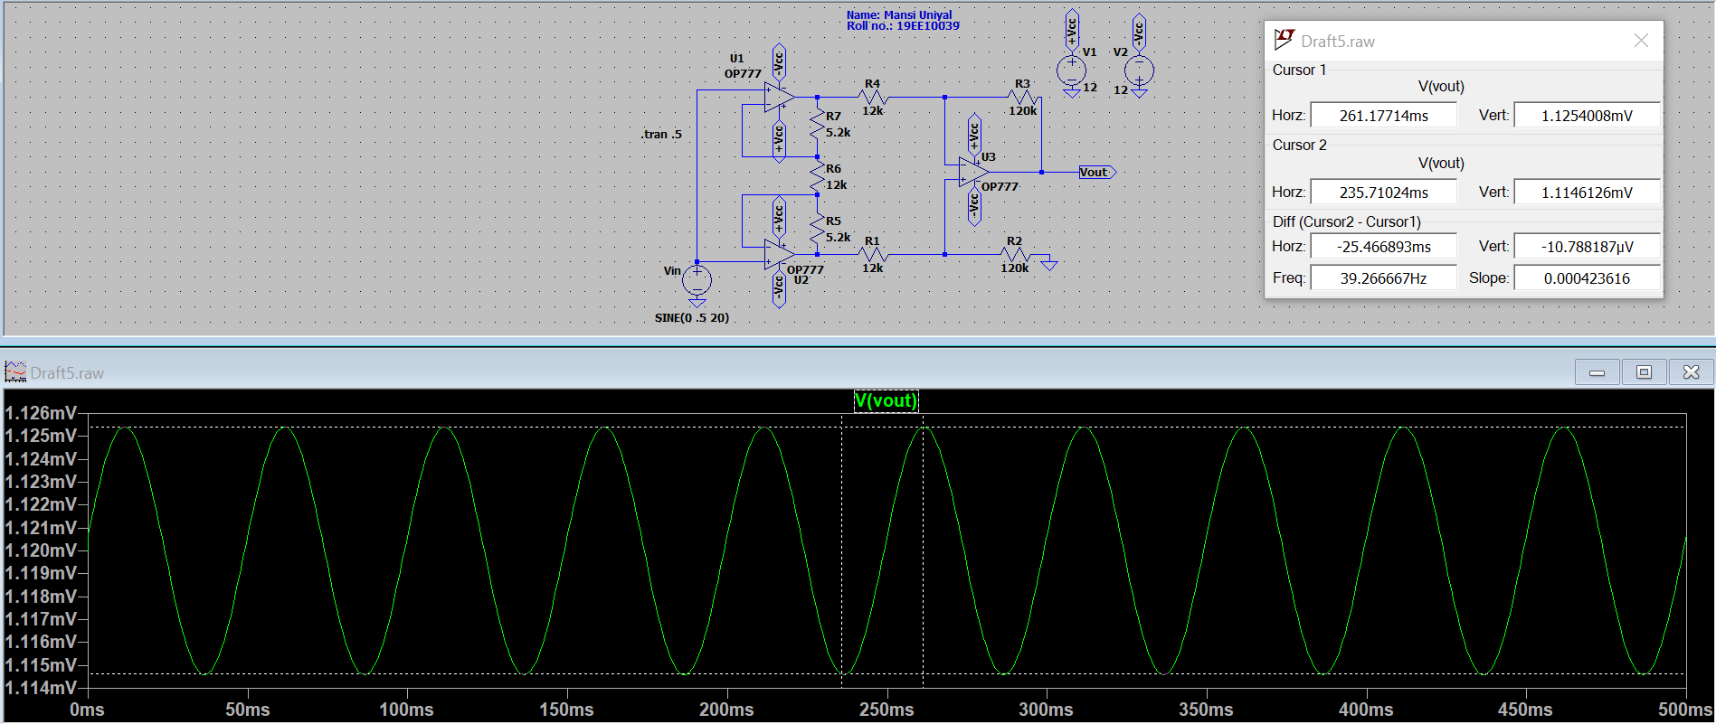

f=30Hz:

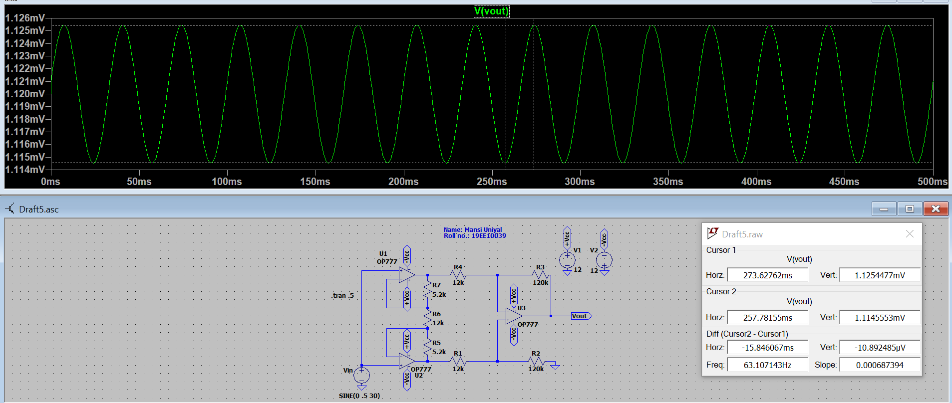

f=40Hz:

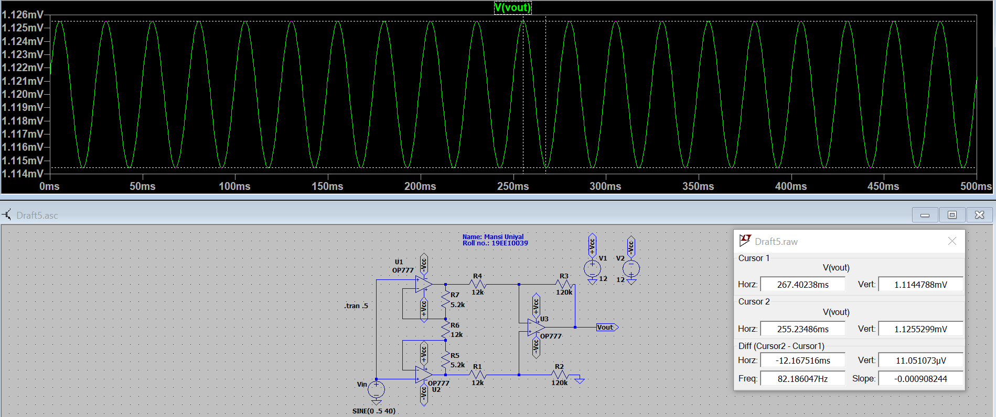

f=50Hz:

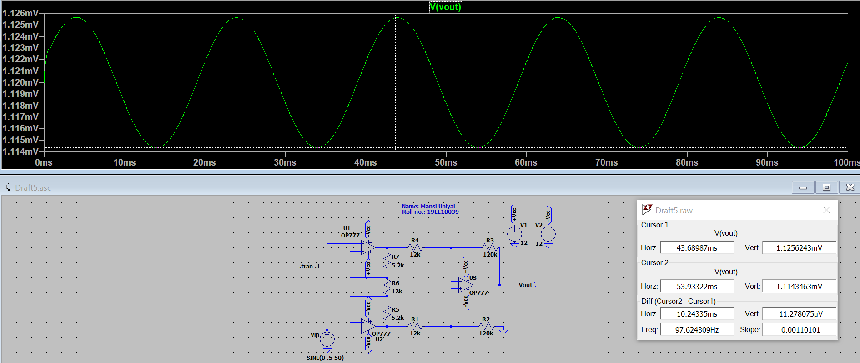

f=60Hz:

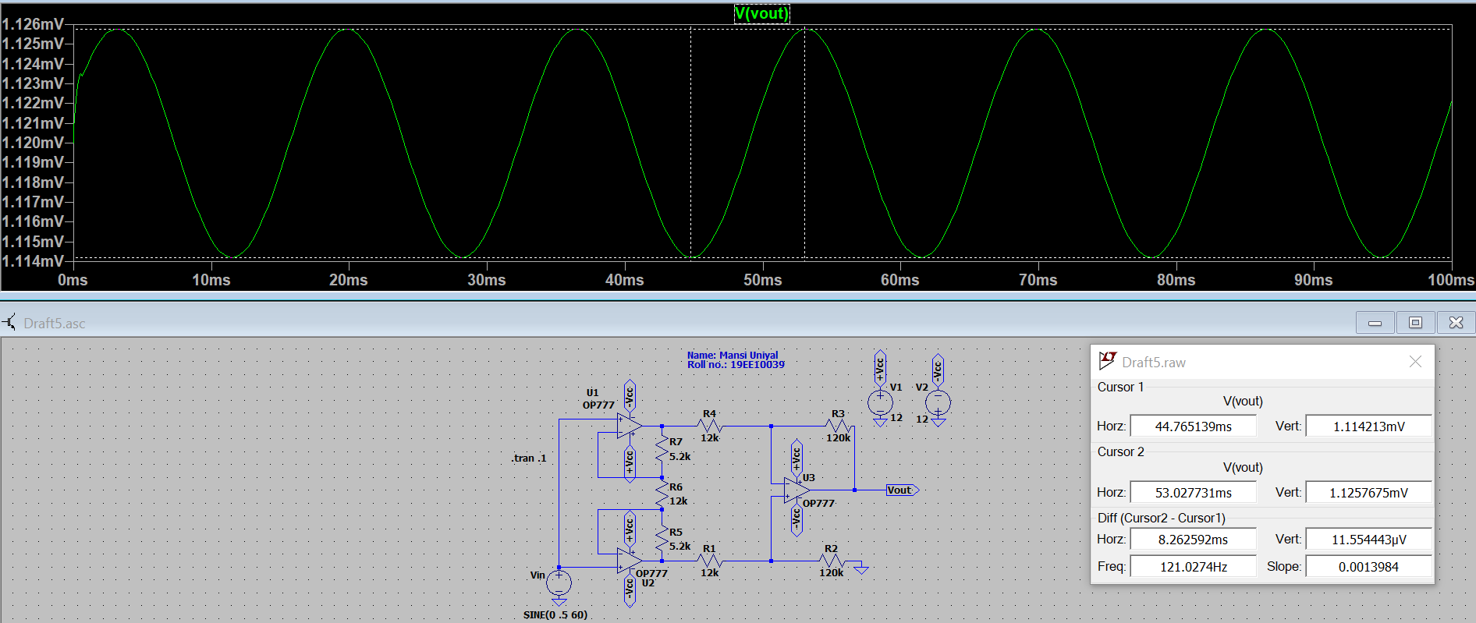

f=70Hz:

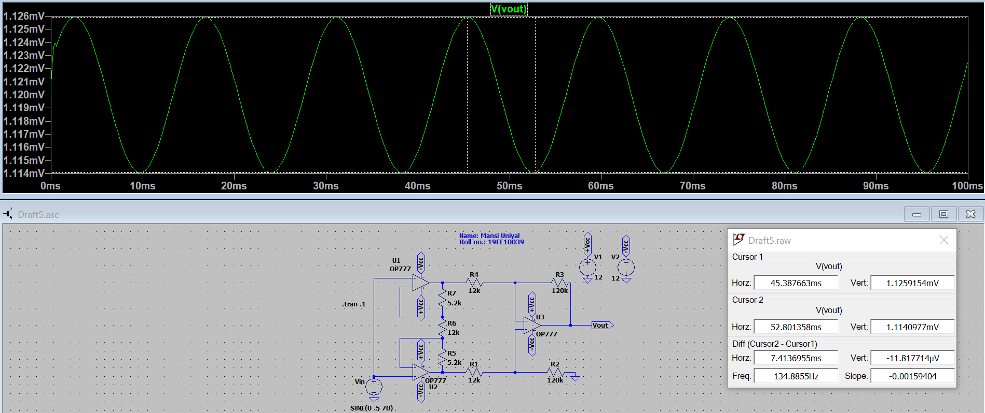

f=80Hz:

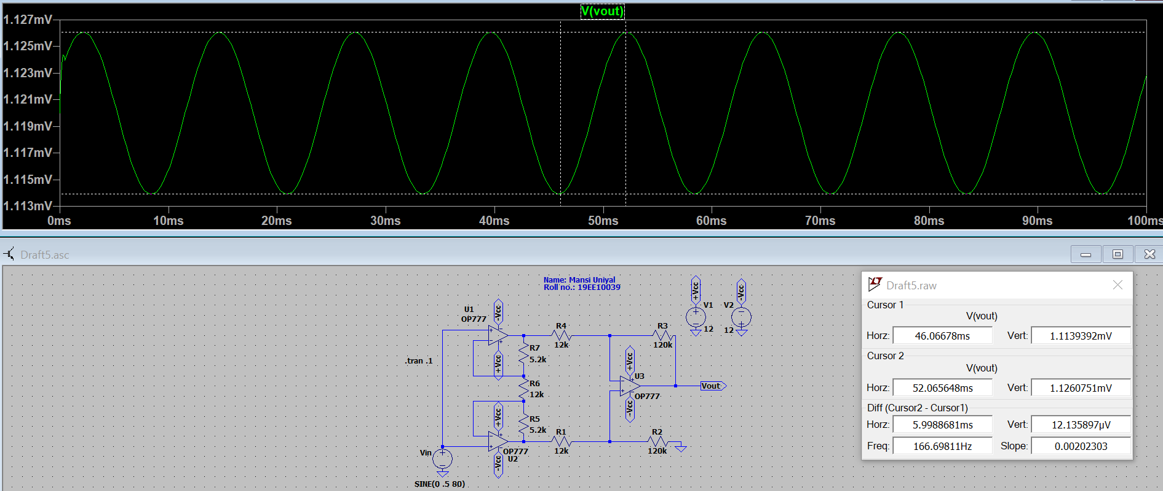

f=90Hz:

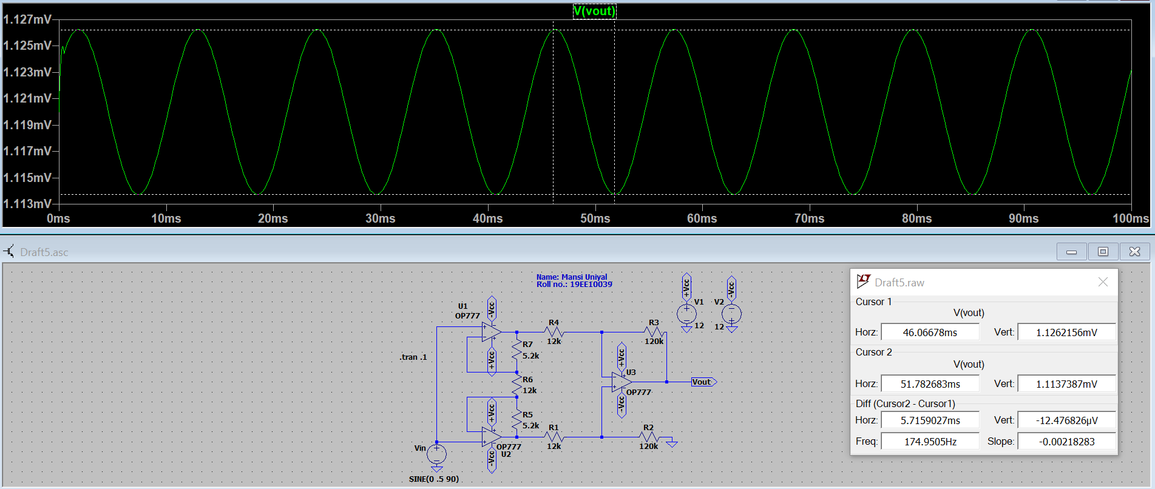

f=100Hz:

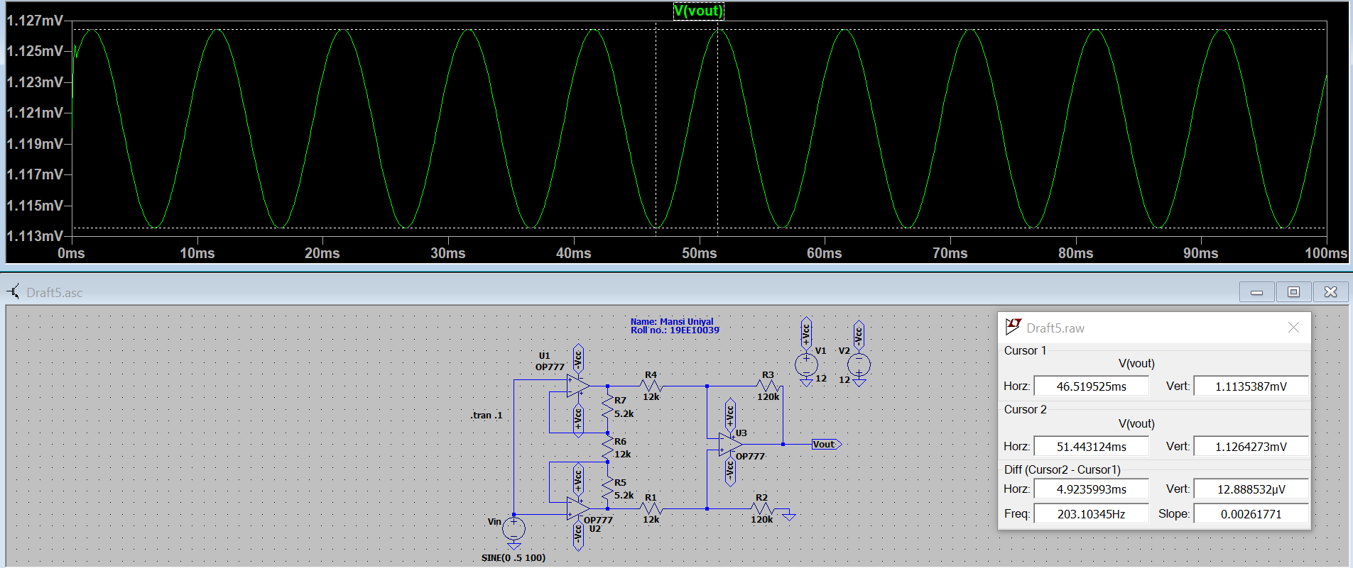

Comment: CMRR stands for Common Mode Rejection Ratio. It is a measure of how well the two halves of the input differential amplifier stage are matched. It is the ratio od Ad and Acm, that is differential and common-mode gain respectively. Ideally, CMRR is infinite. A typical value for CMRR would be 100 dB. Here, the CMRR is observed to be 124 dB. It is observed that the CMRR value decreases for an increase in frequency.

Due to internal capacitors and resistors and the slew rate of the opamp, there is a distortion in the initialization of the Vout graph because of the high value of voltage increase in a short period of time.